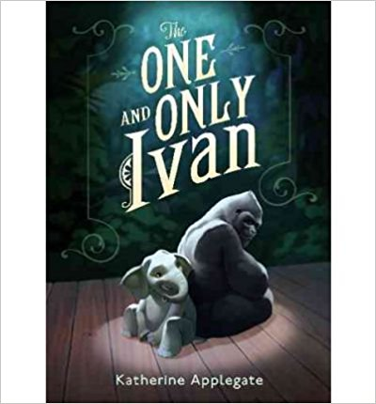
Lexile 560
This unforgettable novel from renowned author Katherine Applegate celebrates the transformative power of unexpected friendship. Inspired by the true story of a captive gorilla known as Ivan, this illustrated book is told from the point of view of Ivan himself. This paperback edition includes an author's note highlighting the differences between the fictional story and true events, a version of the author's Newbery Medal acceptance speech, Ivan's "signature," discussion questions, and more.
Having spent twenty-seven years behind the glass walls of his enclosure in a shopping mall, Ivan has grown accustomed to humans watching him. He hardly ever thinks about his life in the jungle. Instead, Ivan occupies himself with television, his friends Stella and Bob, and painting. But when he meets Ruby, a baby elephant taken from the wild, he is forced to see their home, and his art, through new eyes.

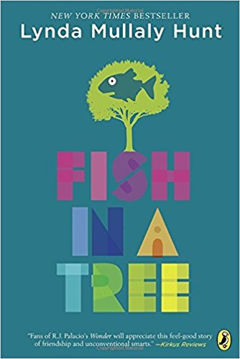
Lexile 550
Ally has been smart enough to fool a lot of smart people. Every time she lands in a new school, she is able to hide her inability to read by creating clever yet disruptive distractions. She is afraid to ask for help; after all, how can you cure dumb? However, her newest teacher Mr. Daniels sees the bright, creative kid underneath the trouble maker. With his help, Ally learns not to be so hard on herself and that dyslexia is nothing to be ashamed of. As her confidence grows, Ally feels free to be herself and the world starts opening up with possibilities. She discovers that there’s a lot more to her—and to everyone—than a label, and that great minds don’t always think alike.

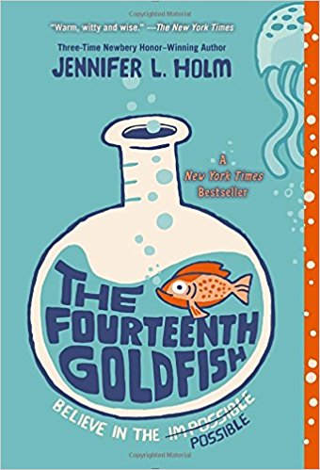
Lexile 550
Eleven-year-old Ellie has never liked change. She misses fifth grade. She misses her old best friend. She even misses her dearly departed goldfish. Then one day a strange boy shows up. He’s bossy. He’s cranky. And weirdly enough . . . he looks a lot like Ellie’s grandfather, a scientist who’s always been slightly obsessed with immortality. Could this gawky teenager really be Grandpa Melvin? Has he finally found the secret to eternal youth?

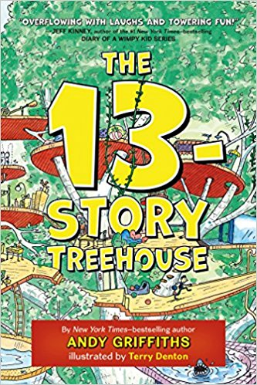
Andy and Terry live in a treehouse. But it's not just any old treehouse, it's the most amazing treehouse in the world!
This treehouse has thirteen stories, a bowling alley, a see-through swimming pool, a secret underground laboratory, and a marshmallow machine that follows you around and automatically shoots marshmallows into your mouth whenever you are hungry.
Life would be perfect for Andy and Terry if it wasn't for the fact that they have to write their next book, which is almost impossible because there are just so many distractions, including thirteen flying cats, giant bananas, mermaids, a sea monsters pretending to be mermaids, enormous gorillas, and dangerous burp gas-bubblegum bubbles!

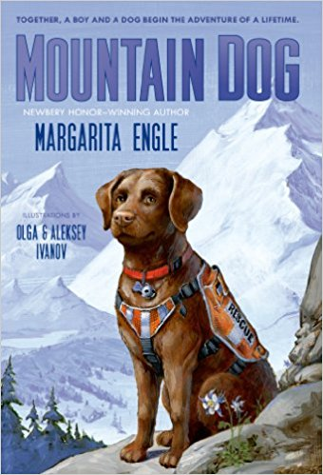
When Tony's mother is sent to jail, he is sent to stay with a great uncle he has never met in Sierra Nevada. It is a daunting move―Tony's new world bears no semblance to his previous one. But slowly, against a remote and remarkable backdrop, the scars from Tony's troubled past begin to heal.
With his Tió and a search-and-rescue dog named Gabe by his side, he learns how to track wild animals, is welcomed to the Cowboy Church, and makes new friends at the Mountain School. Most importantly though, it is through Gabe that Tony discovers unconditional love for the first time, in Mountain Dog by Margarita Engle.

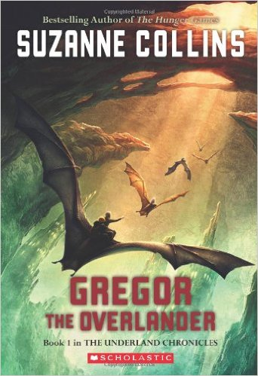
Lexile 630
In the irresistible first novel by the author of The Hunger Games, a boy embarks on a dangerous quest in order to fulfill his destiny -- and find his father. New cover art coming July 1st!
In the first novel of the New York Times bestselling series by Suzanne Collins, author of The Hunger Games, young Gregor falls through a grate in the laundry room of his apartment building and hurtles into the dark Underland. This strange world is on the brink of war, and Gregor's arrival is no accident. A prophecy foretells that Gregor has a role to play in the Underland's uncertain future. Gregor wants no part of it -- until he realizes it's the only way to solve the mystery of his father's disappearance. Gregor embarks on a dangerous adventure that will change both him and the Underland forever.

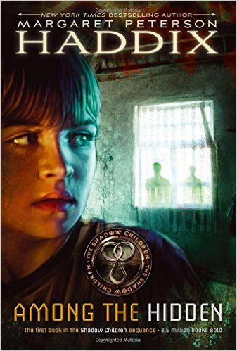
Lexile 800
In a future where the Population Police enforce the law limiting a family to only two children, Luke, an illegal third child, has lived all his twelve years in isolation and fear on his family's farm in this start to the Shadow Children series from Margaret Peterson Haddix.
Luke has never been to school. He's never had a birthday party, or gone to a friend's house for an overnight. In fact, Luke has never had a friend.
Luke is one of the shadow children, a third child forbidden by the Population Police. He's lived his entire life in hiding, and now, with a new housing development replacing the woods next to his family's farm, he is no longer even allowed to go outside.
Then, one day Luke sees a girl's face in the window of a house where he knows two other children already live. Finally, he's met a shadow child like himself. Jen is willing to risk everything to come out of the shadows -- does Luke dare to become involved in her dangerous plan? Can he afford not to?

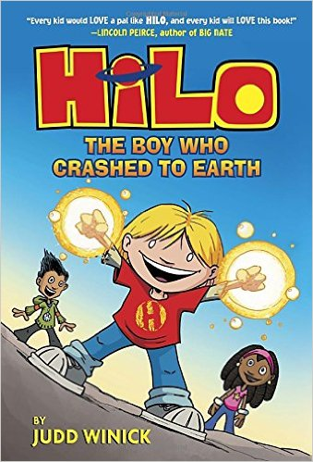
Lexile 220
D.J. and his friend Gina are totally normal kids. But Hilo isn't! Hilo doesn’t know where he came from, or what he’s doing on Earth. (Or why going to school in only your underwear is a BAD idea!) . . . But UH-OH, what if Hilo wasn’t the only thing to fall to our planet? Can the trio unlock the secrets of Hilo's past? Can Hilo SURVIVE a day at school? Find out in HILO-a laugh-out-loud, epic story of friendship! Adventure! (And the occasionaly mutant robot ant).

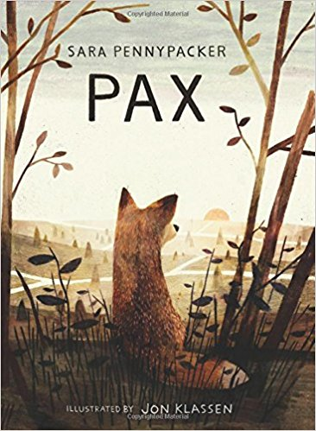
Lexile 760
Pax and Peter have been inseparable ever since Peter rescued him as a kit. But one day, the unimaginable happens: Peter's dad enlists in the military and makes him return the fox to the wild.
At his grandfather's house, three hundred miles away from home, Peter knows he isn't where he should be—with Pax. He strikes out on his own despite the encroaching war, spurred by love, loyalty, and grief, to be reunited with his fox.
Meanwhile Pax, steadfastly waiting for his boy, embarks on adventures and discoveries of his own. . . .

Lexile 900

Matt Christopher, the number one sports writer for kids, profiles basketball superstar Michael Jordan, covering his childhood, college career, rookie years, professional career highlights, and his short stint in minor league baseball. This reissue features an update, following Jordan from his re-entry into basketball as a player for the Washington Wizards to his third and final retirement announcement. With updated photos and Matt Christopher's easy-to-read style, this is a biography that's not to be missed

